**Note on Inclusion: Supporting Children with PMLD and Complex Needs**

The adapted VIP Skills Profile and observation checklist are designed to support all neurodivergent learners — including children with profound and multiple learning disabilities (PMLD), sensory impairments, or those who do not communicate through speech.

These tools can be used flexibly and sensitively, with an understanding that communication and play may look different for each child. Observations might include:

* Eye gaze or changes in facial expression
* Stillness, breath control, or subtle movements
* Vocalisations, anticipation, or rhythmic engagement
* Emotional resonance or co-regulation with a trusted adult

This profile is not about meeting neurotypical milestones. It’s about being present, noticing the child’s unique ways of connecting, and tuning in to their sensory and relational world. All children, regardless of ability, deserve the opportunity to lead us into play.

**Venture Into Play(VIP) Play Skills Profile**

**For children who are neurodivergent**

**Adapted by Ange Anderson, 2025 Based on principles introduced in *Venturing Into Play* (Smith, 2003) and updated for contemporary practice.**

*A baseline assessment needs to be completed by the child’s teacher before requesting VIP. A copy of the baseline assessment for the teacher to copy follows this page.*

**The VIP Play Skills Profile enables those working with a child who is neurodivergent to:**

* Identify the child’s current play skills with reference to three specific dimensions- the social dimension, the developmental dimension and the Schematic play dimension. This enables those using the profile to record:
* the child’s interactions with adults and other children in playful situations
* the developmental stages of the child’s play
* differentiate between natural urges and behaviours

***Schematic Play:***

As part of identifying developmental stages, practitioners may also wish to observe for the presence of play schemas—repetitive patterns of behaviour that reflect the child’s developing understanding of the world. These schemas can provide valuable insight into a child’s internal motivations and how they make sense of their environment. Observing schemas alongside VIP’s developmental and social dimensions can deepen understanding and help differentiate between a child’s natural urges and behaviours that may be misinterpreted. Schema observation can also guide the creation of more responsive, engaging play opportunities tailored to the child's learning needs.

***Monitor and celebrate progress:***

* Identify the progress over time of the child’s play skills through dated descriptive comments and the use of a graduated frequency marker

***Set long term goals and shorter term targets:***

* Review the child’s profile of play skills, consider the emerging skills, strengths and weaknesses and identify targets

The VIP Play Skills Profile does not aim to describe every step in the development of play for individual children, instead it provides useful markers and signposts.

**Those using the profiles are advised to:**

* observe the child at play on a number of occasions
* share and exchange their observations with the child’s parents/carers and other professionals
* circle several profile items which best describe the child’s play (best fit)
* Some professionals may wish to focus on just one or two of the play dimensions
* Write brief descriptions of the play in the description boxes providing clear examples of the child’s play
* Date the entry
* Complete the graduated frequency marker column using the key provided at the bottom of each page
* Complete the further date/description/frequency columns at relevant intervals (e.g. termly).

**VIP Baseline Play Profile – Initial Assessment**

**Child’s Name:** _________________________  
**DOB:** ____________  
**Assessor (TA/Teacher):** _________________________  
**Setting/Class:** _________________________  
**Date of Observation(s):** _________________________

**📘 Purpose of Baseline:**

This form captures a snapshot of the child's current play profile, helping practitioners identify which areas of play are established, emerging, or not yet observed. It can inform targeted play-based support, such as VIP withdrawal sessions.

**🧩 1. Social Dimension**

| **Subcategory** | **Observed? ✅** | **Notes / Example Behaviours** |
| --- | --- | --- |
| 1. Solitary play |  |  |
| 2. Adult coming alongside (2–7) |  |  |
| 3. Adult joins play (8–9) |  |  |
| 4. Adult-child interaction (10–17) |  |  |
| 5. Getting others into play (18–23) |  |  |
| 6. Getting child-child interaction (24–34) |  |  |

**🔧 2. Developmental Dimension**

| **Subcategory** | **Observed? ✅** | **Notes / Example Behaviours** |
| --- | --- | --- |
| 1. Sensory-motor play (1–2) |  |  |
| 2. Relational play (3–5) |  |  |
| 3. Constructional play (6–8) |  |  |
| 4. Cause and Effect play (9–13) |  |  |
| 5. Functional/Representative play (14–18) |  |  |
| 6. Symbolic play (19–22) |  |  |
| 7. Sociodramatic play (23–26) |  |  |

**🔄 3. Schematic Play Dimension**

| **Schema Type** | **Observed? ✅** | **Notes / Example Behaviours** |
| --- | --- | --- |
| 1. Positioning |  |  |
| 2. Rotation |  |  |
| 3. Orientation |  |  |
| 4. Transporting |  |  |
| 5. Enclosing |  |  |
| 6. Connecting |  |  |
| 7. Transformation |  |  |
| 8. Enveloping |  |  |
| 9. Trajectory |  |  |

**✏️ General Notes / Observations:**

# Enhancing the Social Dimension of Play

**How Adults Help**

**Watch!**  
**Listen!**  
**Have Fun!**

* **Observe social signals and interactions**

Pay attention to how children initiate, respond to, or avoid interaction during play. Use these observations to understand their social strengths and challenges.

* **Model positive social behaviours during play**

Demonstrate sharing, turn-taking, empathy, and conflict resolution. Children learn by watching how you play with others.

* **Create opportunities for shared play**

Set up activities that naturally involve more than one child (e.g., building together, turn-based games, role play) to foster collaboration.

* **Use play to introduce emotional language**

Label emotions in play ('Your teddy looks sad') and link feelings to actions. This helps children recognise and express emotions safely.

* **Encourage peer-to-peer communication**

Support children to talk to and listen to one another. Prompt gently when needed: 'Can you ask Jacob if he’d like a turn?'

* **Use puppets, dolls, or small world play to explore relationships**

Children can act out social scenarios using characters, allowing them to experiment with empathy, friendship, and perspective-taking.

* **Validate solitary or parallel play**

Don’t rush children into interaction. Respect their preferred social style while gently offering opportunities to connect.

* **Celebrate all attempts at connecting**

Smile, narrate, and praise even small gestures: a shared smile, a passed toy, a moment of joint attention.

* **Offer simple scripts for social language**

Give children words they can use in social play: 'Can I play too?' or 'My turn now.' Rehearsing these builds confidence.

* **Use group rituals to foster belonging**

Simple songs, circle games, or shared routines help children feel part of a social group and build collective joy.

* **Introduce games with clear, gentle rules**

Cooperative games help children practice turn-taking, waiting, and fairness in a low-pressure way.

* **Reflect on play interactions afterwards**

Chat with children about what happened: 'You and Ava worked really well together on that tower — what was your favourite part?'

**Remember**:  
Social play is where children learn to understand others and feel understood themselves. By tuning in, modelling warmth, and scaffolding interaction gently, adults help children build the foundations of lasting relationships.

Use the Social Dimension Checklist alongside this guide to observe and support children’s social play development

**THEME 1 – THE SOCIAL DIMENSION**

|  |  |  |  |  |  |  |
| --- | --- | --- | --- | --- | --- | --- |
|  | **The Social Dimension** | | When describing play it is helpful to give details about any prompts used to promote play, whether the play occurs with familiar or unfamiliar people to indicate the frequency in the frequency marker column | | | |
|  | **Solitary Play** | | **Description of Play** | | | |
| **1** | **The child engages in solitary play for extended periods but is beginning to show awareness of the playful possibilities of others** | | Date: | | | Frequency  Marker |
| **Adult Coming Alongside** | | | | | | |
| **2** | **The child continues to play in the same room when an adult enters** | | Date: | | | Frequency  Marker |
| **3** | **The child continues to play in the same area when an adult is about two metres away** | | Date: | | | Frequency  Marker |
| **4** | **The child continues to play in the same area when the adult is one metre away** | | Date: | | | Frequency  Marker |
| **Key** | | **Sometimes: seldom** | | **Sometimes: about half the time** | **Sometimes: mostly** |  |
| Frequency Marker | |  | |  |  |

|  |  |  |  |  |  |  |
| --- | --- | --- | --- | --- | --- | --- |
| **The Social Dimension Continued…** | | | **Description of Play** | | | |
| **5** | **The child stays alongside the adult in the same play space** *e.g. on the same play mat/at the same large table* | | Date: | | | Frequency  Marker |
| **6** | **The child stays alongside the adult at the same piece of large equipment**  *e.g. Sand tray, water tray, floor jigsaw* | | Date: | | | Frequency  Marker |
| **7** | **The child tolerates an adult commentary on, or imitation of, their play**  *e.g. adult commenting on child’s play in a natural way e.g. adult imitating child’s play actions* | | Date: | | | Frequency  Marker |
| **Adult joining play** | | | | | | |
| **8** | **The child participates in rough and tumble games with an adult** | | Date: | | | Frequency  Marker |
| **9** | **The child participates in face to face action rhyme games** *e.g. see saw Marjorie Daw, Row Row Row your boat* | | Date: | | | Frequency  Marker |
| **Key** | | **Sometimes: seldom** | | **Sometimes: about half the time** | **Sometimes: mostly** |  |
| Frequency Marker | |  | |  |  |

|  |  |  |  |  |  |  |
| --- | --- | --- | --- | --- | --- | --- |
| **The Social Dimension Continued…** | | | **Description of Play** | | | |
| **10** | **The child indicates a desire for the adult to continue the game**  *e.g. child requests more by gesture, saying ‘again’ or eye contact* | | Date: | | | Frequency  Marker |
| **11** | **The child initiates an action game with an adult**  *e.g. fetches a relevant toy to show adult, moves hands to prompt a known action song* | | Date: | | | Frequency  Marker |
| **12** | **The child accepts the adult acting as a tool in toy play**  *e.g. adult putting train back on track, giving shapes for posting, winding the lift of a garage* | | Date: | | | Frequency  Marker |
| **13** | **The child watches adult’s play**  *e.g. child glances over to adult when adult playing nearby* | | Date: | | | Frequency  Marker |
| **14** | **The child tolerates the adult prompting the child to use a toy of adult’s choice** *e.g. hand over hand prompting to work jack in the box* | | Date: | | | Frequency  Marker |
| **Key** | | **Sometimes: seldom** | | **Sometimes: about half the time** | **Sometimes: mostly** |  |
| Frequency Marker | |  | |  |  |

|  |  |  |  |  |  |  |
| --- | --- | --- | --- | --- | --- | --- |
| **The Social Dimension Continued…** | | | **Description of Play** | | | |
| **15** | **The child engages actively in a simple joint game with an adult**  *e.g. Pop up toy, bubbles, pushing a car down ramp* | | Date: | | | Frequency  Marker |
| **16** | **The child engages in a range (approx 5) of joint attention activities with an adult, taking an active part in games** *e.g. Xylophone, sharing a puzzle, blowing bubbles, action songs* | | Date: | | | Frequency  Marker |
| **17** | **The child engages in ‘formalised’ turn taking games with an adult**  *e.g. turn taking building a tower, completing a jigsaw* | | Date: | | | Frequency  Marker |
| **Getting others into the play (eg. Another adult and/or child)** | | | | | | |
| **18** | **The child engages in ‘formalised’ turn taking games with 2 others** *e.g. lotto with 2 adults or another child and adult* | | Date: | | | Frequency  Marker |
| **19** | **The child initiates joint attention play with a range of toys**  *e.g. gets bubbles out, brings adult or another child to the play area* | | Date: | | | Frequency  Marker |
| **Key** | | **Sometimes: seldom** | | **Sometimes: about half the time** | **Sometimes: mostly** |  |
| Frequency Marker | |  | |  |  |

# Enhancing the Developmental Dimension of Play

|  |  |  |  |  |  |  |
| --- | --- | --- | --- | --- | --- | --- |
| **The Social Dimension Continued…** | | | **Description of Play** | | | |
| **20** | **The child initiates a joint attention or turn taking game with 2 people**  *e.g. action song with 2 adults or adult and child* | | Date: | | | Frequency  Marker |
| **21** | **The child follows visual prompts for play**  *e.g. adult models and provides a 3 picture sequence of a story using a car, a house and a petrol pump, child imitates independently* | | Date: | | | Frequency  Marker |
| **22** | **The child follows adult’s instructions or demonstration**  *e.g. how to play e.g. in play ‘let’s make tea’* | | Date: | | | Frequency  Marker |
| **23** | **The child initiates house play with adult** | | Date: | | | Frequency  Marker |
| **Getting Child – Child Interaction** | | | | | | |
| **24** | **The child stays in (defined) play area when other child present**  *e.g. sand tray, at table* | | Date: | | | Frequency  Marker |
| **Key** | | **Sometimes: seldom** | | **Sometimes: about half the time** | **Sometimes: mostly** |  |
| Frequency Marker | |  | |  |  |

|  |  |  |  |  |  |  |
| --- | --- | --- | --- | --- | --- | --- |
| **The Social Dimension Continued…** | | | **Description of Play** | | | |
| **20** | **The child initiates a joint attention or turn taking game with 2 people**  *e.g. action song with 2 adults or adult and child* | | Date: | | | Frequency  Marker |
| **21** | **The child follows visual prompts for play**  *e.g. adult models and provides a 3 picture sequence of a story using a car, a house and a petrol pump, child imitates independently* | | Date: | | | Frequency  Marker |
| **22** | **The child follows adult’s instructions or demonstration**  *e.g. how to play e.g. in play ‘let’s make tea’* | | Date: | | | Frequency  Marker |
| **23** | **The child initiates house play with adult** | | Date: | | | Frequency  Marker |
| **Getting Child – Child Interaction** | | | | | | |
| **24** | **The child stays in (defined) play area when other child present**  *e.g. sand tray, at table* | | Date: | | | Frequency  Marker |
| **Key** | | **Sometimes: seldom** | | **Sometimes: about half the time** | **Sometimes: mostly** |  |
| Frequency Marker | |  | |  |  |

|  |  |  |  |  |  |  |
| --- | --- | --- | --- | --- | --- | --- |
| **The Social Dimension Continued…** | | | **Description of Play** | | | |
| **25** | **The child watches what the other children are doing** | | Date: | | | Frequency  Marker |
| **26** | **The child accepts 2 or more children sharing the same big piece of play equipment**  *e.g. 2-3 children at the sand tray* | | Date: | | | Frequency  Marker |
| **27** | **The child enjoys physical play with other child(ren)**  *e.g. tickling* | | Date: | | | Frequency  Marker |
| **28** | **The child tolerates the involvement of other child(ren) in his play**  e.g. another child shovels sand into his/her bucket | | Date: | | | Frequency  Marker |
| **29** | **The child joins 2-3 other children for a circle game**  *e.g. Ring-a-Ring-a-Roses* | | Date: | | | Frequency  Marker |
| **Key** | | **Sometimes: seldom** | | **Sometimes: about half the time** | **Sometimes: mostly** |  |
| Frequency Marker | |  | |  |  |

|  |  |  |  |  |  |  |
| --- | --- | --- | --- | --- | --- | --- |
| **The Social Dimension Continued…** | | | **Description of Play** | | | |
| **30** | **The child takes a turn in a physical game with other child(ren)**  **e.g. throwing and catching, playing skittles** | | Date: | | | Frequency  Marker |
| **31** | **The child imitates other children at play** | | Date: | | | Frequency  Marker |
| **32** | **The child seeks play with other children** | | Date: | | | Frequency  Marker |
| **33** | **The child maintains involvement in other children’s playing despite spontaneous changes in the direction of the play**  *e.g. the child continues to play even when the play moves from cops and robbers to dinosaur hunt to bus trip etc* | | Date: | | | Frequency  Marker |
| **34** | **The child copes calmly with other children deciding that the playing is over** | | Date: | | | Frequency  Marker |
| **Key** | | **Sometimes: seldom** | | **Sometimes: about half the time** | **Sometimes: mostly** |  |
| Frequency Marker | |  | |  |  |

|  |  |
| --- | --- |
| **Date** | **Language Development** |
| *You may wish to photocopy this page in order to write more notes* |
|  | **Language and Communication Development**  **Date:** **Child’s Name:**  This space is for recording **new or emerging communication skills** noticed during play. These may be **verbal or non-verbal**, spontaneous or prompted, and may include interactions with adults or peers.  Please consider noting any of the following:   * Gestures (e.g. pointing, waving, leading someone by the hand) * Facial expressions used to communicate * Vocalisations or babble * New words or phrases * Use of symbols or signs (e.g. Makaton, PECS) * Attempts to initiate or respond in play * Sharing attention (e.g. looking at an object then an adult) * Requests (e.g. reaching, vocalising, exchanging) * Commenting or narrating during play * Any attempts at imaginative or social speech   **Observation notes:** |

**How Adults Help**

**Watch!**  
**Listen!**  
**Have Fun!**

**Keep observational records and set developmental targets**  
Regularly observe children’s play to note new skills, interests, and areas for growth.

Use these observations to plan next steps.

**Set aside dedicated time for play**  
Ensure children have regular, uninterrupted periods for free play and adult-guided

play, supporting all areas of development.

**Organise the play environment thoughtfully**  
Select toys and arrange spaces to encourage a range of developmental skills—physical,

social, emotional, cognitive, and language.

**Provide opportunities for repetition and positive reinforcement**  
Allow children to practise new skills and celebrate their efforts, fostering confidence

and mastery.

**Offer a commentary on the child’s play**  
Describe what the child is doing, using rich language to support understanding,

vocabulary, and social interaction.

**Establish routines and use visual structures**  
Predictable routines and visual cues help children feel secure and support transitions

between activities.

**Model and narrate your own play**  
Show children how to use toys and materials, thinking aloud to demonstrate problem-

solving and imagination.

**Use ‘first, then’ strategies to support transitions**  
Help children move between activities smoothly: “First we tidy up, then we can read

a story.”

**Imitate the child’s play to build connection**  
Reflect their actions and ideas, showing interest and encouraging turn-taking and

shared focus.

**Demonstrate and teach appropriate use of toys**  
Guide children in exploring materials safely and creatively, introducing new ways to play

as needed.

**Follow the child’s interests to extend learning**  
Use their fascinations as a springboard for introducing new concepts and skills.

* **Encourage generalisation of skills**  
  Support children in applying what they learn in play to new situations, materials,
* and social contexts.
* **Teach and model the concept of ‘pretend’**  
  Encourage imaginative and symbolic play, helping children understand and
* participate in make-believe scenarios.
* **Introduce story sequences visually and interactively**  
  Use picture cards, toys, and books to help children understand and retell
* stories, supporting language and memory.

**Remember:**  
Developmental play is the foundation for lifelong learning. By providing a rich,

supportive, and joyful play environment, adults help children grow across all areas—physically, emotionally, socially, and cognitively.

# Theme 2 The Developmental DimensionEnhancing the Schematic Dimension of Play

|  |  |  |  |  |  |  |
| --- | --- | --- | --- | --- | --- | --- |
|  | **The Developmental Dimension** | | *When describing play it is helpful to give detail about any prompts used to promote play, whether the play occurs with familiar or unfamiliar people. Indicate the frequency in the frequency marker column* | | | |
|  | **Sensory – motor play** | | **Description of Play** | | | |
| **1** | **The child happily plays with tactile toys/ materials**  *e.g. playdough, sand, water, finger paints* | | Date: | | | Frequency  Marker |
| **2** | **The child explores a range of toys (specify number) using appropriate sensory investigation** *e.g. looking at or touching trains, cars, garage etc* | |  | | | Frequency  Marker |
| **Relational Play** | | | | | | |
| **3** | **The child relates toys/ objects unsystematically**  *e.g. bangs objects together, piles up objects* | | Date: | | | Frequency  Marker |
| **4** | **The child relates to objects systematically**  e.g. puts bricks in to dumper truck, spoon in to cup, strings beads, nests toys, puts pegs in peg board, bangs drum with intent | | Date: | | | Frequency  Marker |
| **Key** | | **Sometimes: seldom** | | **Sometimes: about half the time** | **Sometimes: mostly** |  |
| Frequency Marker | |  | |  |  |

|  |  |  |  |  |  |  |
| --- | --- | --- | --- | --- | --- | --- |
| **Developmental Dimension Cont.** | | | **Description of Play** | | | |
| **5** | **The child completes a simple puzzle/form board or simple 3-4 piece shape sorter** | | Date: | | | Frequency  Marker |
| **Constructional Play** | | | | | | |
| **6** | **The child builds a tower of 3 bricks or 3 beakers** | | Date: | | | Frequency  Marker |
| **7** | **The child fits together 4 – 5 Duplo blocks or snap lock beads** | | Date: | | | Frequency  Marker |
| **8** | **The child fits together 6 – 7 Duplo blocks to forma a model**  *e.g. makes a bridge* | | Date: | | | Frequency  Marker |
| **Cause and Effect Play** | | | | | | |
| **9** | **The child makes a toy work**  *e.g. shakes rattle to make noise, presses button to make clown pop up, presses button on push down car* | | Date: | | | Frequency  Marker |
| **Key** | | **Sometimes: seldom** | | **Sometimes: about half the time** | **Sometimes: mostly** |  |
| Frequency Marker | |  | |  |  |

|  |  |  |  |  |  |  |
| --- | --- | --- | --- | --- | --- | --- |
| **Developmental Dimension Cont.** | | | **Description of Play** | | | |
| **10** | **The child searches for, and finds, objects during play**  *e.g. when object falls off table, when sound making object is hidden under cushion* | | Date: | | | Frequency  Marker |
| **11** | **The child uses an object to obtain another item**  *e.g. pulls a table cloth with the object on it to get the object* | | Date: | | | Frequency  Marker |
| **12** | **The child climbs to reach a toy**  *e.g. uses a step or a stool* | | Date: | | | Frequency  Marker |
| **13** | **The child uses objects intentionally to produce cause and effect play**  *e.g. rolls ball and knocks skittles down, pours water or sand through water wheel, uses hammer to knock balls through holes.* | | Date: | | | Frequency  Marker |
| **Functional/Representative Play** | | | | | | |
| **14** | **The child uses real object on self**  **e.g. brushes own hair in imitation.** | | Date: | | | Frequency  Marker |
| **Key** | | **Sometimes: seldom** | | **Sometimes: about half the time** | **Sometimes: mostly** |  |
| Frequency Marker | |  | |  |  |

|  |  |  |  |  |  |  |
| --- | --- | --- | --- | --- | --- | --- |
| **Developmental Dimension Cont.** | | | **Description of Play** | | | |
| **15** | **The child ‘self pretends’ using toy objects on self**  *e.g. uses miniature brush to brush own hair* | | Date: | | | Frequency  Marker |
| **16** | **The child uses toy objects on adult**  *e.g. brushes adult’s hair with toy brush* | | Date: | | | Frequency  Marker |
| **17** | **The child ‘doll pretends’ using toy object on doll or teddy**  *e.g. feeds teddy with spoon* | | Date: | | | Frequency  Marker |
| **18** | **The child sequences ‘pretend’ play activities using toy objects**  *e.g. feeds doll then self, gives dolly a bath and puts to bed* | | Date: | | | Frequency  Marker |
| **Symbolic Play** | | | | | | |
| **19** | **The child pretends that one object is another**  *e.g. a block is a biscuit.* | | Date: | | | Frequency  Marker |
| **Key** | | **Sometimes: seldom** | | **Sometimes: about half the time** | **Sometimes: mostly** |  |
| Frequency Marker | |  | |  |  |

|  |  |  |  |  |  |  |
| --- | --- | --- | --- | --- | --- | --- |
| **Developmental Dimension Cont.** | | | **Description of Play** | | | |
| **20** | **The child pretends that a toy object has real properties**  *e.g. the toy stove is hot, the lion roars* | | Date: | | | Frequency  Marker |
| **21** | **The child pretends that a toy person has feelings**  *e.g. dolly is tired/hurt, teddy is angry* | | Date: | | | Frequency  Marker |
| **22** | **The child engages in small world play re-enacting activities from their own experience**  *e.g. the little figures take a bath or fall off their bicycle* | | Date: | | | Frequency  Marker |
| **Sociodramatic Play** | | | | | | |
| **23** | **The child joins an adult or child in a familiar, predictable make believe play routine**  *e.g. making a cup of tea, driving the car to the station* | | Date: | | | Frequency  Marker |
| **24** | **The child initiates a make-believe play routine with an adult or child(ren)** | |  | | | Frequency  Marker |
| **Key** | | **Sometimes: seldom** | | **Sometimes: about half the time** | **Sometimes: mostly** |  |
| Frequency Marker | |  | |  |  |

|  |  |  |  |
| --- | --- | --- | --- |
| **Developmental Dimension Cont.** | | **Description of Play** | |
| **25** | **The child joins in the make-believe play of others** | Date: | Frequency  Marker |
| **26** | **The child joins in the make-believe play of others, coping with the frequent changes in the content and nature of the play**  *e.g. the child readily changes character with the flow of the play, being a policeman one moment and a doctor the next* | Date: | Frequency  Marker |
| **Notes and Comments** | | | |
|  |  |  |  |

**How Adults Help**

**Watch!**  
**Listen!**  
**Be Curious! Have Fun!**

* **Observe and record schematic interests**  
  Note the patterns in the child’s play (e.g., transporting, enclosing, trajectory) and keep brief records of emerging schemas.
* **Set aside uninterrupted time for schematic exploration**  
  Allow for deep, focused play where children can repeat actions and test their ideas.
* **Organise the environment to support schemas**  
  Offer materials and spaces that encourage different schemas (e.g., ramps for trajectory, boxes for enclosing, bags for transporting).
* **Provide opportunities for safe repetition**  
  Recognize and allow repetition as essential for learning and celebrate perseverance.
* **Narrate the child’s schematic play**  
  Offer language that matches their actions: “You’re rolling the car down the ramp again and again. Well done!”
* **Model schematic exploration yourself**  
  Join in and demonstrate similar actions, showing curiosity and enjoyment.
* **Follow the child’s interests and fascinations**  
  Notice which schemas are most engaging and provide related materials or experiences.
* **Encourage combining and extending schemas**  
  Support children as they mix different schemas (e.g., building and enclosing, or transporting and connecting).
* **Offer visual supports and routines**  
  Use pictures or routines to help children predict and plan their play, especially when introducing new materials.
* **Use ‘first, then’ strategies**  
  “First we build a tower, then you can knock it down!”
* **Imitate and expand on the child’s actions**  
  Copy what the child does, then add a new twist or idea to inspire further exploration.
* **Demonstrate safe and creative ways to explore schemas**  
  Show how to throw, drop, fill, or connect objects safely and inventively.
* **Encourage storytelling around schemas**  
  Use books, stories, or picture cards that reflect schematic interests (e.g., stories about things that go, or characters who hide and find).
* **Celebrate individuality and creativity**  
  Value each child’s unique way of exploring and expressing their schematic interests.

**Remember:**  
Schematic play is how children make sense of the world. Understanding schemas also helps us reframe what we sometimes label as “naughty” or “disruptive” behaviour. Instead of seeing a child as difficult, we begin to see a child with **a powerful urge to explore**.

When schools design learning environments that support schemas, they’re nurturing natural curiosity — not fighting against it. Because schemas aren’t optional. They’re instinctive. They’re essential. They’re **how children learn.**

* **THEME 3 – THE SCHEMATIC PLAY DIMENSION**

|  |  |  |  |  |  |  |
| --- | --- | --- | --- | --- | --- | --- |
|  | **The Schematic Play Dimension** | | When describing schematic play include the *meaning, concept, or idea* that the child is investigating through their actions, as this reveals their current developmental interests and guides how best to support their learning. Note how often behaviours are observed using the frequency marker key below. | | | |
|  | **Schematic Play** | | **Description of Play** | | | |
| **1 Positioning** | **The child arranges objects in rows or lines e.g. lining up cars, blocks, or animals** | | Date: | | | Frequency  Marker |
| **2 Rotation** | **The child shows fascination with spinning objects or themselves e.g. wheels, tops, or turning round in circles.** | | Date: | | | Frequency  Marker |
| **3Orientation** | **The child changes perspective by turning upside down, lying sideways, or viewing from unusual angles** | | Date: | | | Frequency  Marker |
| **4Transporting** | **The child moves objects from one place to another, often repeatedly e.g. filling bags, pushing prams, carrying baskets** | | Date: | | | Frequency  Marker |
| **Key** | | **Sometimes: seldom** | | **Sometimes: about half the time** | **Sometimes: mostly** |  |
| Frequency Marker | |  | |  |  |

|  |  |  |  |  |  |  |
| --- | --- | --- | --- | --- | --- | --- |
| **The Schematic Dimension continued** | | | **Description of Play** | | | |
| **5 Enclosing** | **The child creates boundaries around objects or themselves e.g. placing blocks in a circle or climbing into boxes** | | Date: | | | Frequency  Marker |
| **6 Connecting** | **The child joins materials together e.g. taping, tying, clipping, or building long trains or chains**   |  | | --- | | | Date: | | | Frequency  Marker |
| **7 Transforming** | **The child enjoys changing substances or materials e.g. mixing colours, cooking play, or playing with wet/dry textures** | | Date: | | | Frequency  Marker |
| **8 Enveloping** | **The child wraps, covers, or hides objects or themselves e.g. wrapping toys in fabric or hiding under blankets** | | Date: | | | Frequency  Marker |
| **9 Trajectory** | **The child explores movement through throwing, dropping, swinging, or watching objects move through space** | | Date: | | | Frequency  Marker |
| **Key** | | **Sometimes: seldom** | | **Sometimes: about half the time** | **Sometimes: mostly** |  |
| Frequency Marker | |  | |  |  |

# Venturing Into Play Summary Sheet

## Social Dimension

|  |  |
| --- | --- |
| Social Dimension | Notes on Social Dimension |
| 1. Solitary play |  |
| 2. Adult coming alongside (2–7) |  |
| 3. Adult joins play (8–9) |  |
| 4. Adult-child interaction (10–17) |  |
| 5. Getting others into play (18–23) |  |
| 6. Getting child-child interaction (24–34) |  |

## Developmental Dimension

|  |  |
| --- | --- |
| Developmental Dimension | Notes on Developmental Dimension |
| 1. Sensory-motor play (1–2) |  |
| 2. Relational play (3–5) |  |
| 3. Constructional play (6–8) |  |
| 4. Cause and Effect play (9–13) |  |
| 5. Functional/Representative play (14–18) |  |
| 6. Symbolic play (19–22) |  |
| 7. Sociodramatic play (23–26) |  |

## Schematic Play Dimension

|  |  |
| --- | --- |
| Schematic Play Dimension | Notes on Schematic Play Dimension |
| 1. Positioning Schema |  |
| 2. Rotation Schema |  |
| 3. Orientation Schema |  |
| 4. Transporting Schema |  |
| 5. Enclosing Schema |  |
| 6. Connecting Schema |  |
| 7. Transformation Schema |  |
| 8. Enveloping Schema |  |
| 9. Trajectory Schema |  |

This tool supports deeper understanding of children’s play and reframes behaviour as meaningful learning in action.

Based on the original Venturing Into Play (Smith, 2003) Play Skills Profile. Updated for contemporary practice by Ange Anderson in 2025 to support neurodivergent children in inclusive and therapeutic educational settings. This version is an independent adaption and is not affiliated with or endorsed by the original author.

**Venturing into Play**

**Is it successful?**

Venturing Into play has become very successful for children in the foundation phase. Venturing into Play has helped reach targets, encourage the children to play with others & it has become a place where children feel calm this is then allowing them to explore their imagination.

Here are some examples of how Venturing into play has helped children achieve their targets throughout the current school year.

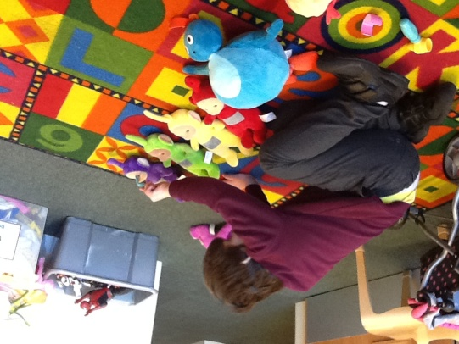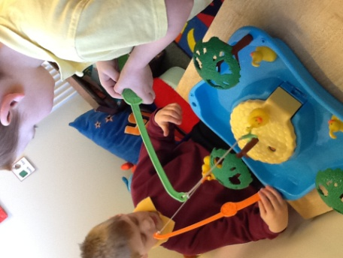

Target – Choose to work or play alongside peer.

Comment –

Pupil enjoyed playing a fishing duck game during VIP, they took turns when hooking the ducks.

Target – Contingency awareness

Comment–

Pupil has been attending Venturing into play and has begun showing Contingency awareness when playing with toys.

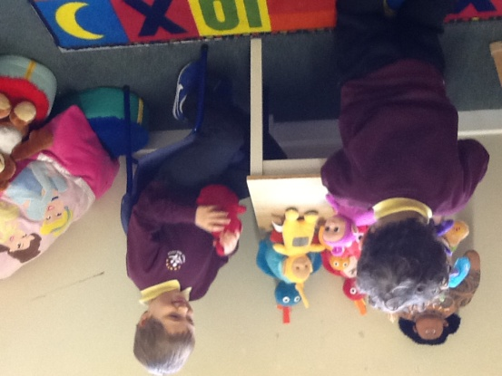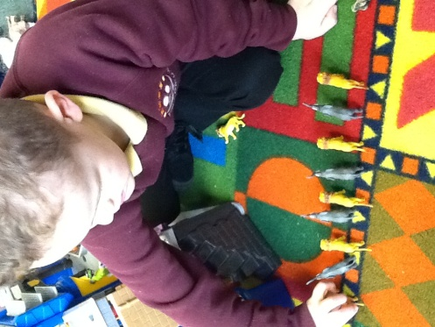

Target– Locate & remove favourite object from among a collection of different objects.

Comment–Pupil searched through the collection of teddies and chose his most liked.

Target –Will copy simple patterns & Sequences.

Comment – Pupil watched adult line up elephant, lion etc. Pupil then searched for the animals in the box and copied the sequence.

Target – Joins in play briefly with others.

Comment – Pupil enjoyed playing with hook a duck game with friend during VIP.

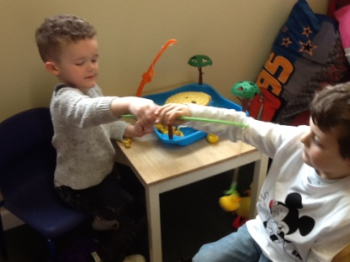

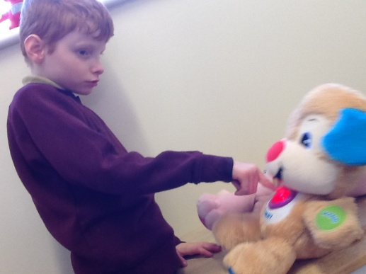

**Individual Session Recording (***photocopy for future sessions)*

**Activity – Venturing into Play (VIP)**

**Name: Term: Class: Teacher:**

Target –

Comments –

Target –

Comments –

Target –

Comments –

Target –

Comments –

|  |  |
| --- | --- |
| **Evaluation** | **Any Suggestions** |
|  |  |

